Project Report

Team members:
Muhi Al Habboush 20220469,
Aws Abdullah 20230862,
Hamza jarrar 20210857.

1. Introduction & Approach
- The objective: Automatic text summarization is an essential task in NLP which aims to generate a meaningful summary of a document while preserving its key information. Our project focuses on abstractive text summarization which generates new condensed sentences to capture a document’s core meaning. We have built a neural Sequence-to-Sequence system to map long Arabic news articles into short and meaningful summaries.

2. Data Preprocessing
- To build our model, we combined and loaded the provided Arabic summarization datasets into one massive training corpus. We cleaned the raw text using regular expressions to strip out optional diacritics (tashkeel), elongation marks, punctuation, and non-Arabic characters entirely. We also normalized inconsistent letter forms to shrink the overall vocabulary. After filtering, we built our shared vocabulary space by explicitly fitting the tokenizer on both the cleaned input articles and target summaries combined. Finally, we processed the remaining clean samples by capping the vocabulary at 30,000 words, adding boundary tokens, and padding input articles to 400 tokens and summaries to 50 tokens.

3. Model Architecture Design
- We implemented an Attention-Based Seq2Seq model using Keras and TensorFlow. The input tokens pass through a 128-dimensional embedding layer. For the encoder, we used a Bidirectional LSTM with 256 units that outputs a rich, concatenated 512-dimensional vector, and for our decoder, we used a 512-unit standard LSTM initialized directly with the encoder's final states. To improve summary quality, we integrated a custom Bahdanau attention mechanism which dynamically weights encoder outputs at each step, and passes that context to a softmax dense layer to predict the next word.

4. Training Curves & Quantitative Results
- Our training was conducted on the training split of the dataset with early stopping monitored on the validation set. We used Adam optimizer and sparse categorical crossentropy loss to optimize our model. Our training converged successfully and halted early at Epoch 8. As shown in the inserted plot below, the loss steadily decreases while accuracy improves. To assess our summaries, we applied evaluation metrics such as ROUGE-1, ROUGE-2, and ROUGE-L scores. Our final evaluation on the test set resulted in a ROUGE-1 score of 0.1345, a ROUGE-2 score of 0.0162, and a ROUGE-L score of 0.1043.

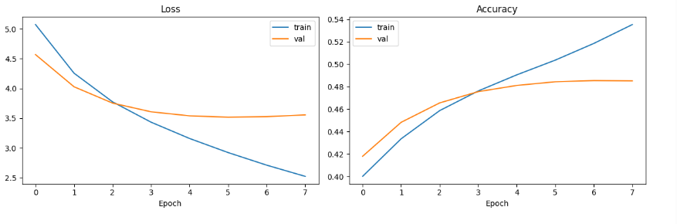

5. Qualitative & Error Analysis

For the interface, we implemented standard greedy decoding while applying a strict generation ban on out-of-vocabulary (<OOV>) tokens and empty padding sequences to maintain vocabulary consistency without relying on historical lookback penalties. We then performed a qualitative analysis by comparing reference summaries against sample generated summaries. The results show that our model successfully learns proper Arabic sentence structure and identifies specific keywords. However, it often hallucinates specific facts or mixes entities. This happens because greedy decoding strictly selects the immediate next word rather than planning out full semantic and factual alignments across the entire sentence.

 | Reference Summary (Gold Standard) | Model Generated Summary (Abstractive Output)
Example 1 | ستيف بانون، مستشار ترامب السابق هو راءد اليمين الشعبوي بامريكا والان يريد بانون للانتقال الي بروكسل وانشاء حركه يمينيه شعبويه في اوروبا، كي تمثل ثقلا في مواجهه المستثمر جورج سوروس، الذي يدعم مجموعات ليبراليه | بعد ان ادلي به الرءيس الامريكي دونالد ترامب في الانتخابات الرءاسيه الامريكيه في الانتخابات الرءاسيه الامريكيه، اعلن الرءيس الامريكي دونالد ترامب ان بلاده لن يكون له في الانتخابات المقبله
Example 2 | المانيا تتخذ تدابير للحد من تدفق اعداد جديده من اللاجءين اليها ووجهات نظر الصحف الالمانيه تتباين في تقييمها لهذه التدابير، خاصه في ظل الاجراءات المعلنه في دول اخري كالسويد وفنلندا | في خطوه تهدف الي تشكيل لجنه حكومي جديد في المانيا، طالب وزير التعليم الالماني هورست زيهوفر الي امكانيه التوصل الي اتفاق حول سياسه اللجوء باللاجءين في المانيا

Sample Outputs:
